- Create a MVC application to demonstrate the use of Httpget and Httppost.

Code:

Model: Employee.cs
using System;
using System.Collections.Generic;
using System.Linq;
using System.Web;
namespace Practical_10A.Models
{
public class Employee
{
public string Name { get; set; }
public string Address { get; set; }
public int Age { get; set; }
} }

Controller: HomeController.cs
using System;
using System.Collections.Generic;
using System.Linq;
using System.Web;
using System.Web.Mvc;
using Practical_10A.Models;
namespace Practical_10A.Controllers
{
public class HomeController : Controller
{
[HttpGet]
public ActionResult Index()
{
Employee emp = new Employee()
{
Address = "Nerul",
Name = "Ajay",
Age = 89
};
return View(emp);
}
[HttpPost]
public ActionResult Index(Employee emp)
{
return View("DisplayData", emp);
}
} }

Views:
Index.cshtml
@model Practical_10A.Models.Employee
@{
Layout = null;
}
<!DOCTYPE html>
<html>
<head>
<meta name="viewport" content="width=device-width" />
<title>Index</title>
</head>
<body>
<div>
@using (Html.BeginForm("Myform"))
{
@Html.TextBoxFor(x => x.Name) <br /> <br /> <br />
@Html.TextBoxFor(x => x.Address) <br /> <br /> <br />
@Html.TextBoxFor(x => x.Age) <br /> <br /> <br />
<input type="submit" value="submit" />
}
</div>
</body>
</html>

DisplayData.cshtml
@model Practical_10A.Models.Employee
@{
Layout = null;
}
<!DOCTYPE html>
<html>
<head>
<meta name="viewport" content="width=device-width" />
<title>DisplayData</title>
</head>
<body>
<div>
<h1>Employee Details</h1>
<p>Employee Name: @Model.Name</p>
<p>Employee Age: @Model.Age</p>
<p>Employee Address: @Model.Address</p>
</div>
</body>
</html>

Output:
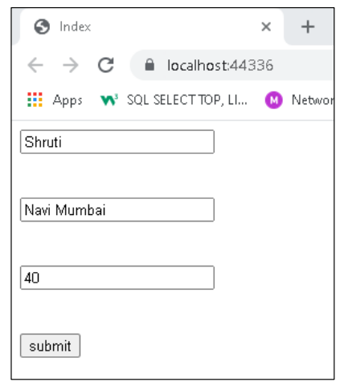

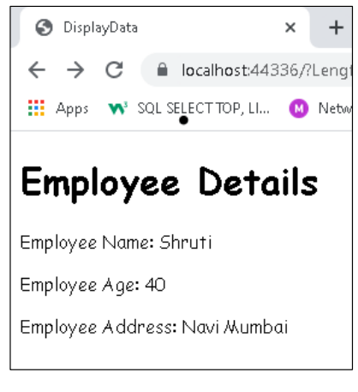

- Create a MVC application to Edit,Create, Delete and to display the data from the database using ADO.net Entity Model.

Step 1: Create a new ASP.Net application with MVC in core references selected and add ADO.Net Entity Data Model Select an EF designer from the DB model.

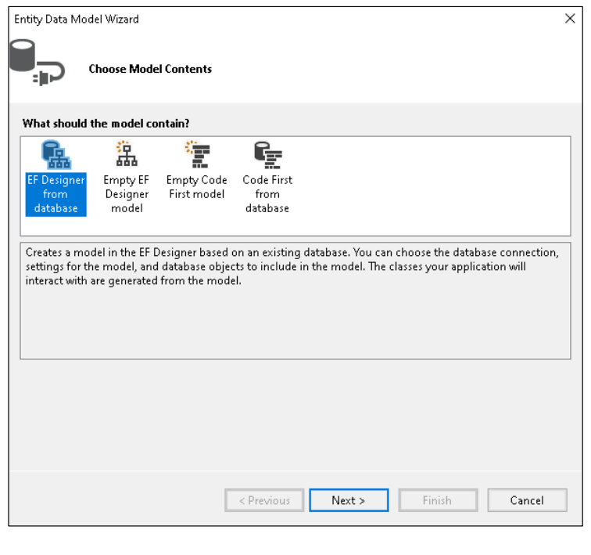

Step 2: Make a connection, test connection, and select desired database.
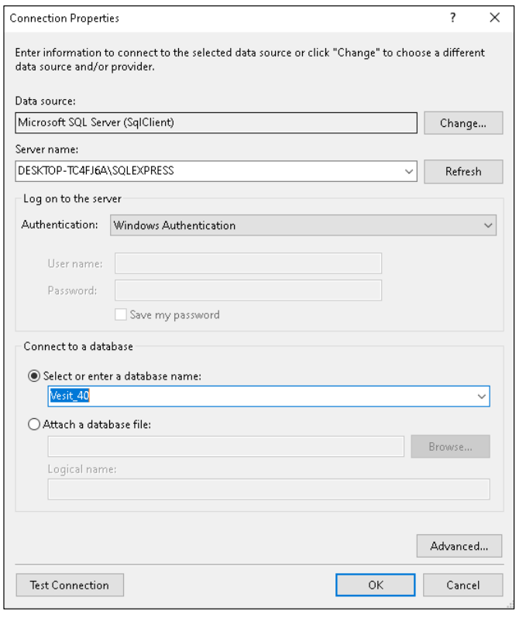

Step 3: Choose the desired Table which shows later in a.edmx file.

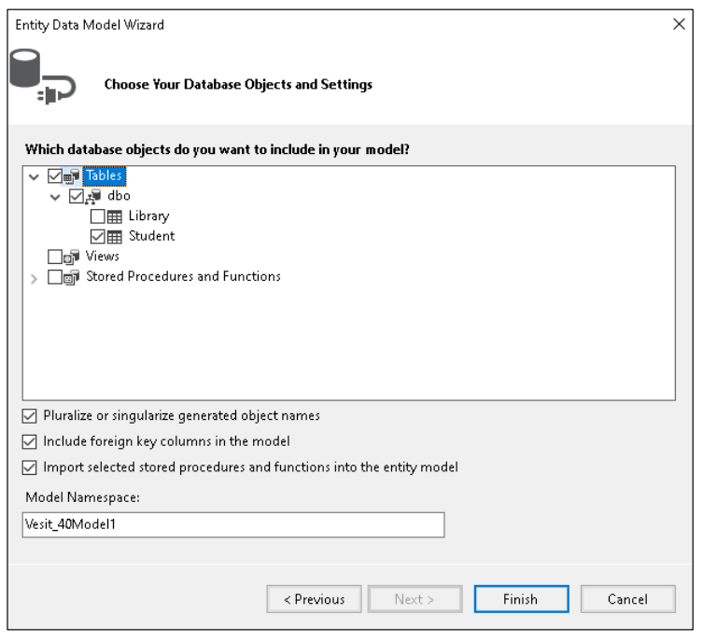
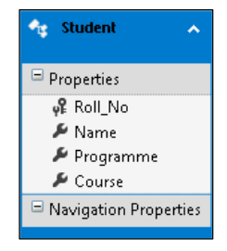

Step 4: Right-click on the controller and add a new controller and select the one with MVC5 with views and click add.
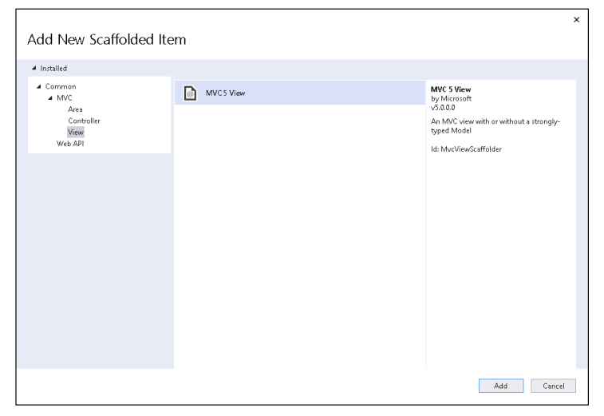
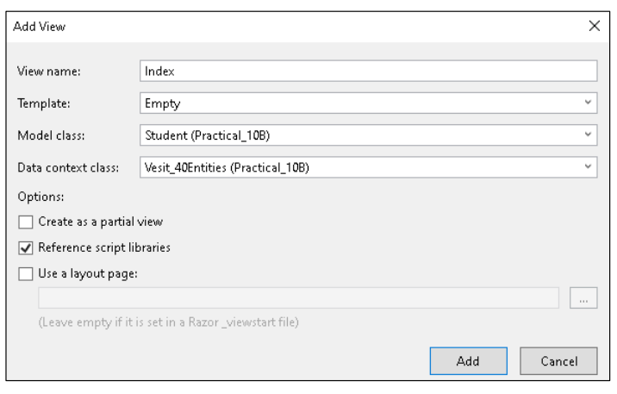

Step 5: Ensure the routeConfig.cs file in AppStart folder has correct details of controller and view you wish to run.

using System;
using System.Collections.Generic;
using System.Linq;
using System.Web;
using System.Web.Mvc;
using System.Web.Routing;
namespace Practical_10B
{
public class RouteConfig
{
public static void RegisterRoutes(RouteCollection routes)
{
routes.IgnoreRoute("{resource}.axd/{*pathInfo}");
routes.MapRoute(
name: "Default",
url: "{controller}/{action}/{id}",
defaults: new { controller = "Students", action =
"Index", id = UrlParameter.Optional }
);
}
}
}

Step 6: Now run the generated code file.
using System;
using System.Collections.Generic;
using System.Data;
using System.Data.Entity;
using System.Linq;
using System.Net;
using System.Web;
using System.Web.Mvc;
using Practical_10B;
namespace Practical_10B.Controllers
{
public class StudentsController : Controller
{
private Vesit_40Entities db = new Vesit_40Entities();
// GET: Students
public ActionResult Index()
{
return View(db.Students.ToList());
}
// GET: Students/Details/5
public ActionResult Details(int? id)
{
if (id == null)
{
return new
HttpStatusCodeResult(HttpStatusCode.BadRequest);
}
Student student = db.Students.Find(id);
if (student == null)
{
return HttpNotFound();
}
return View(student);
}
// GET: Students/Create
public ActionResult Create()
{
return View();
}
// POST: Students/Create
[HttpPost]
[ValidateAntiForgeryToken]
public ActionResult Create([Bind(Include =
"Roll_No,Name,Programme,Course")] Student student)
{
if (ModelState.IsValid)
{
db.Students.Add(student);
db.SaveChanges();
return RedirectToAction("Index");
}
return View(student);
}
// GET: Students/Edit/5
public ActionResult Edit(int? id)
{
if (id == null)
{
return new
HttpStatusCodeResult(HttpStatusCode.BadRequest);
}
Student student = db.Students.Find(id);
if (student == null)
{
return HttpNotFound();
}
return View(student);
}
// POST: Students/Edit/5
[HttpPost]
[ValidateAntiForgeryToken]
public ActionResult Edit([Bind(Include =
"Roll_No,Name,Programme,Course")] Student student)
{
if (ModelState.IsValid)
{
db.Entry(student).State = EntityState.Modified;
db.SaveChanges();
return RedirectToAction("Index");
}
return View(student);
}

// GET: Students/Delete/5
public ActionResult Delete(int? id)
{
if (id == null)
{
return new
HttpStatusCodeResult(HttpStatusCode.BadRequest);
}
Student student = db.Students.Find(id);
if (student == null)
{
return HttpNotFound();
}
return View(student);
}
// POST: Students/Delete/5
[HttpPost, ActionName("Delete")]
[ValidateAntiForgeryToken]
public ActionResult DeleteConfirmed(int id)
{
Student student = db.Students.Find(id);
db.Students.Remove(student);
db.SaveChanges();
return RedirectToAction("Index");
}
protected override void Dispose(bool disposing)
{
if (disposing)
{
db.Dispose();
}
base.Dispose(disposing);
}
}
}

Output:

